Project Data Flow Diagram

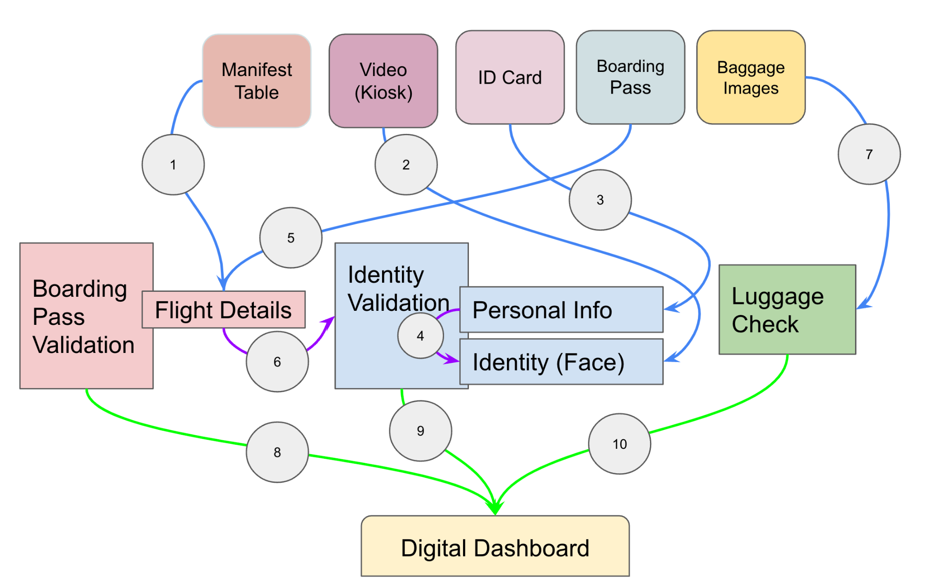

**Explaining:**

1. Manifest table has list of all passengers in the plane
2. Video input is used to identify the face
3. ID card info is used to setup the passenger identity
4. Face from ID is matched with face from video in “Identity Validation”
5. Boarding pass data is matched with the flight details
6. Flight details are matched with Identity validation for personal info checking
7. Baggage data is used for luggage check
8. Boarding pass validation is done
9. Identity Validation is done
10. Baggage check validation is done